Data Collection and Preprocessing Phase

Date | 3 Dec 2025
Team ID
Project Title | Restaurant Recommendation System
Maximum Marks | 6 Marks

Data Exploration and Preprocessing Template

Section | Description
Data Overview | 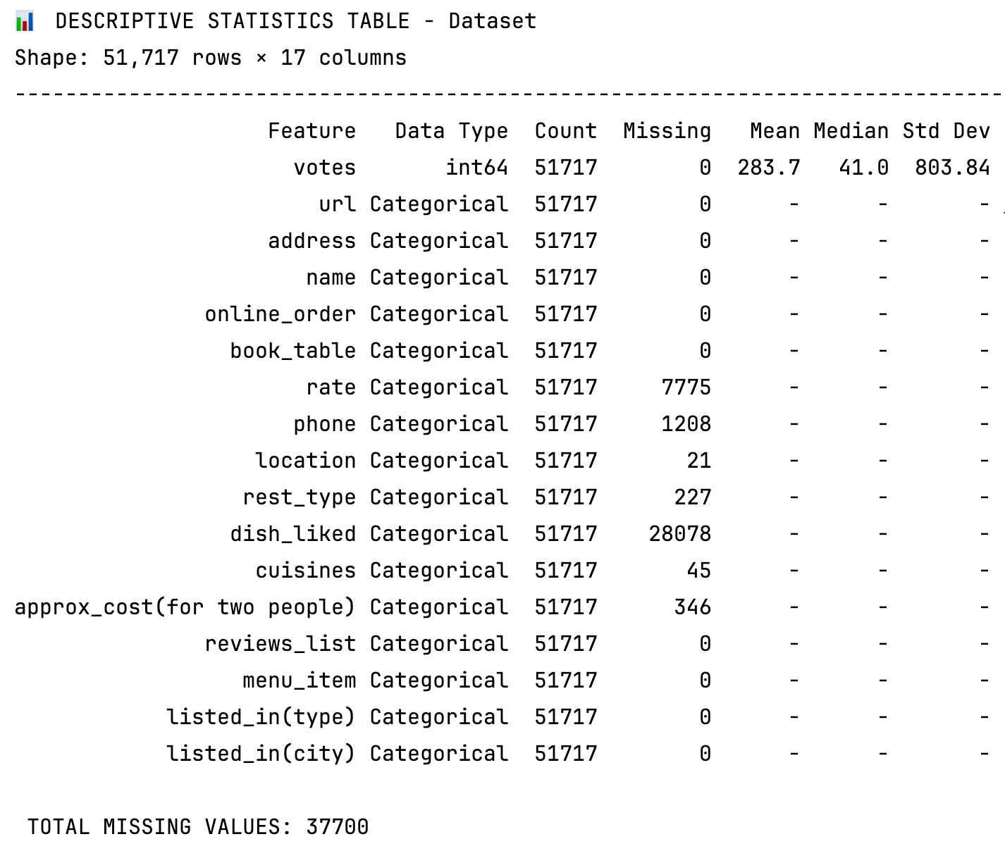
Univariate Analysis | 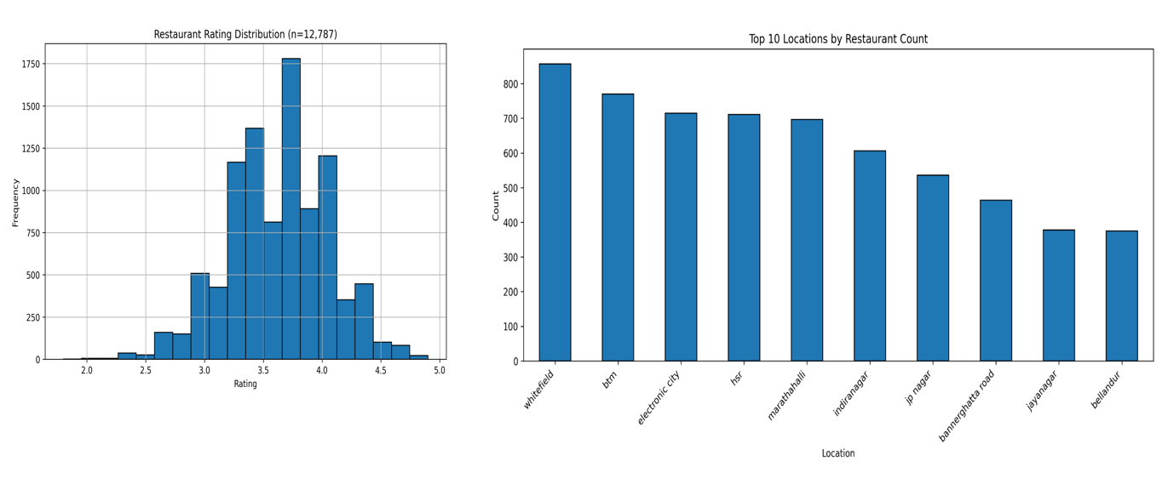
Bivariate Analysis | 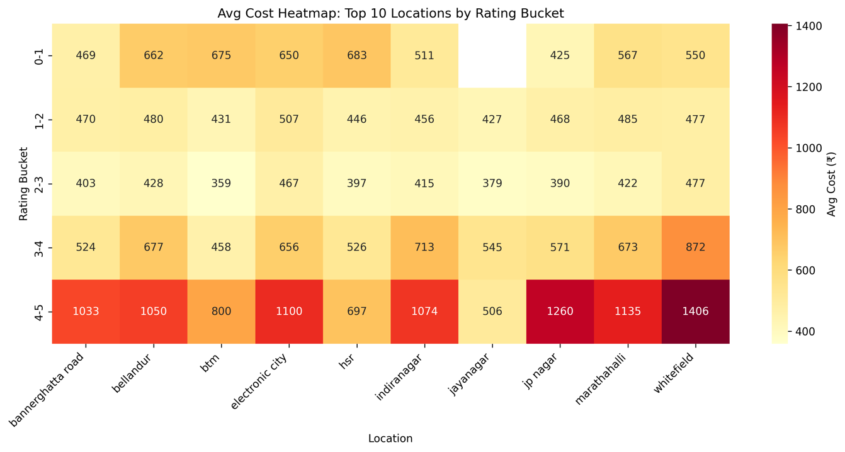
Outliers and Anomalies | Rate >5 or <1 (clipped); cost >10k (z-score >3, capped); anomalies: duplicate addresses (removed).
Data Preprocessing Code Screenshots
Loading Data | 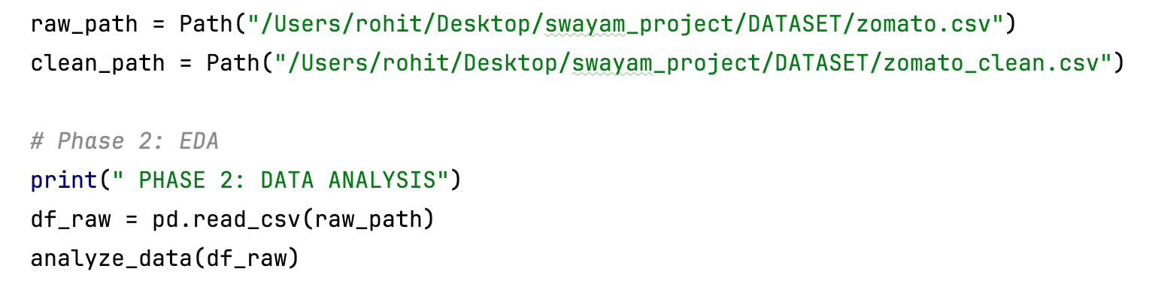
Handling Missing Data | 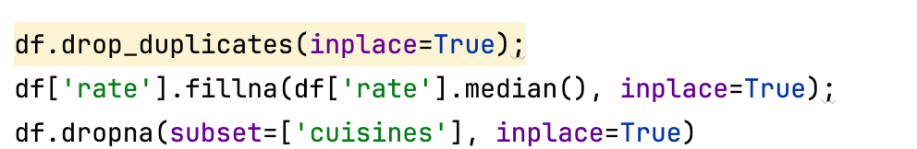
Data Transformation | 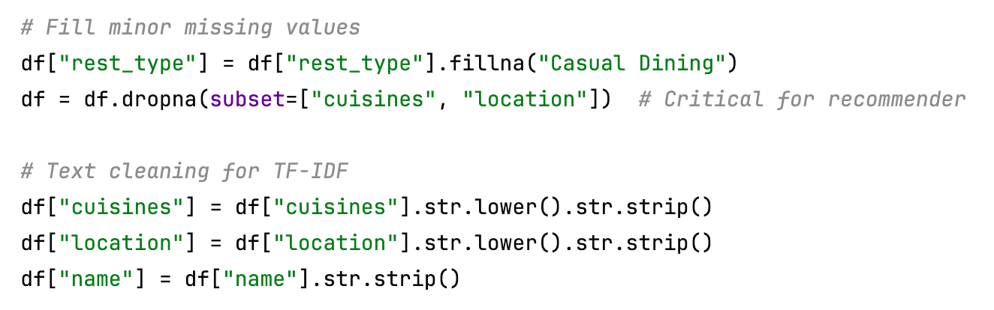
Feature Engineering | 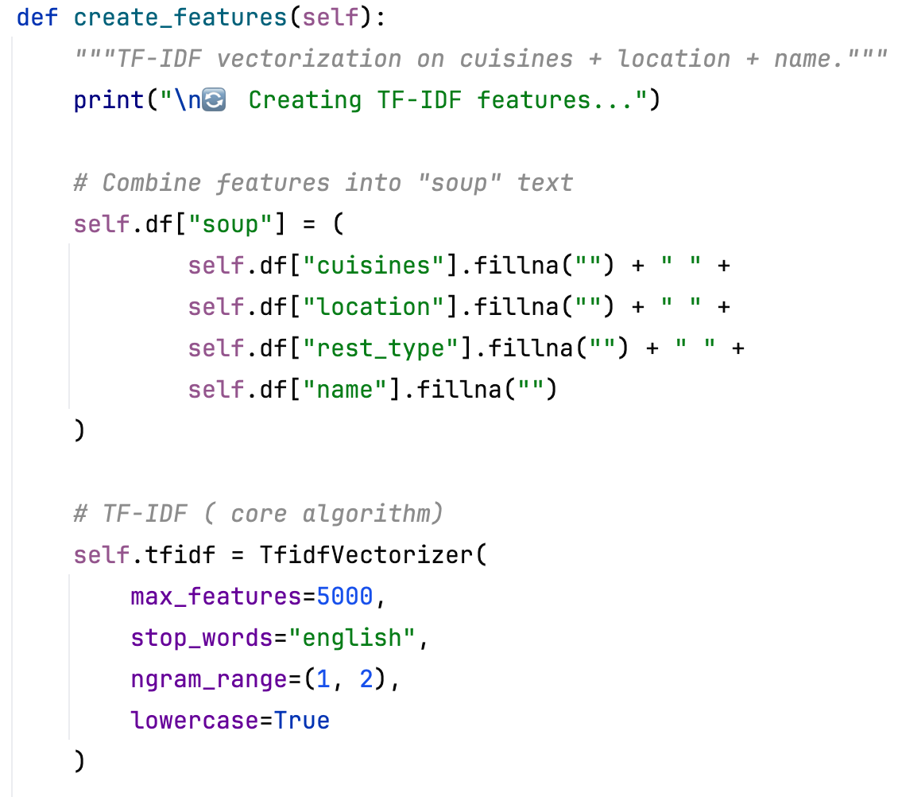
Save Processed Data | 